**AUTOMATIC HUMP CONTROLLER FOR EMERGENCY VEHICLES BY USING WIFI TECHNOLOGY**

Subhash1, Prabakaran2,Naveen kumar3, Prem kumar4, India1 2 3 4

Associate Professor, Department of ECE, Adhiyamaan college of engineering, Hosur, Tamilnadu, India1

UG Student, Department of ECE, Adhiyamaan college of engineering, Hosur, Tamilnadu, India2 3 4

ABSTRACT: In this world, Emergency vehicles moving in the traffic area is very crucial task and the presence of hump slows down the movement of vehicles. This problem can be overcome by using WIFI Technology with point to point protocol. The Transmitter of the WIFI module is to be fitted in the emergency vehicles (ambulance and fire services). In the other side the Receiver can be fixed to the hump along with a microcontroller. When the transmitter comes into range of receiver, the hump is reduced to level of the road. Then the emergency vehicle maintains with same speed while crossing the hump. This operation is controlled by the DC motor and allows the ambulance drivers to work efficiently and effectively that results in saving a humans life.

KEYWORDS: WIFI-wireless fidelity

.

1. **Introduction**

### The emergency vehicles passing the traffic area is very difficult and also present of humps slows down the movement of vehicles. During this time the patients suffers a lot in the emergency vehicles. So this problem is overcome by using wifi technology. The wifi is the technology used for wireless communication between the senders to receiver. Nodemcu is an open source LUA based firmware developed for ESP8266 wifi chip. The **ESP8266** is a low-cost Wi-Fi manufactured by Espressif System with TCP/IP protocol. It is specially designed for wifi communication. It has inbuilt of wifi module with microcontroller. The server of node MCU (microcontroller and esp8266wifi module) is fitted in the emergency vehicles. In the other side the client of node MCU can be fixed to the hump along with a relay. If the server of nodemcu comes close within the range of client, the IP address of wifi signal from server is paired with the IP address of client. The IP address establishes the connection between server and client automatically through input and output pin. Then the client passes the electric pulses to the 5v single channel relay via attached with dc motor. So it cause the hump goes to the level of road automatically. After the certain time the hump back to its original position. Our project provides the way for emergency vehicles without any disturbances make it automated. It works on efficiently and effectively. It makes the emergency vehicles maintain same speed at any time. So this vehicle reaches their exact location at certain time.

This paper is organized as follows; section II presents the block diagram. Section III presents the circuit diagram of the paper which represents the connection between the server and client. Section IV presents the experimental results of the working condition. Finally Section V presents conclusion.

1. RELATED WORK

The main idea of this project is to control hump while crossing the emergency vehicles in the road without any intervention. This idea is proposed by using wifi technology with point to point protocol. Fig 1 shows the block diagram and it is summarized as follow as

1. The transmitter of WIFI module (Nodemcu) is fixed to the emergency vehicle with by using power supply.
2. In hump, the receiver of WIFI module (Nodemcu) is fixed and it is connected to the DC motor .The transmitter and receiver is gets into contact automatically transmitter passes signal to the receiver.
3. Then the receiver of WIFI module is used to control the DC electric motor. DC motor operates the hump goes up & down to level of the road.
4. After certain time the mismatch of WIFI transmitter and receiver module the hump return its own position.
5. This process repeated again and again while the emergency vehicles cross the road.

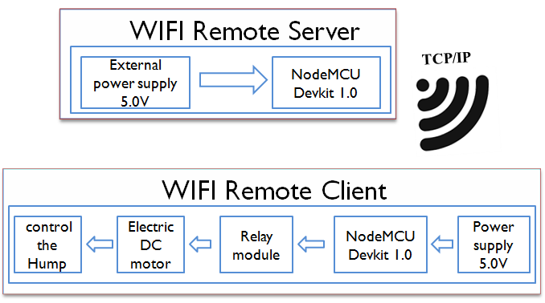

Fig.1. Block Diagram

1. CIRCUIT DIAGRAM

This following figure shows that circuit connection between remote server (emergency vehicles) and remote client (Hump) by using wifi technology with point to point protocol. Initially, the nodemcu in the emergency vehicles provides the hotspot signal and that signal will be received by the nodemcu in the hump easily by using certain Id and password. It makes the motor up and down action for certain time based on application program in ardiuno IDE.

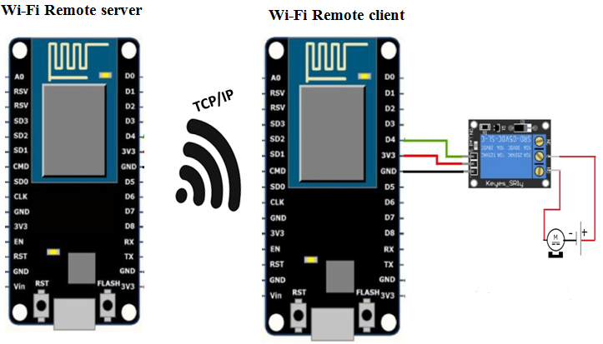

Fig.2. Circuit diagram between server and client

1. Experimental results

The following figure shows that the basic setup between server and client.Fig.3 Basic setup of Server and client in ardiuno IDE Fig.4 represents the paired connection between two nodemcu in the server and client. Fig 5 represents the working of hump while crossing the emergency vehicle in the road.

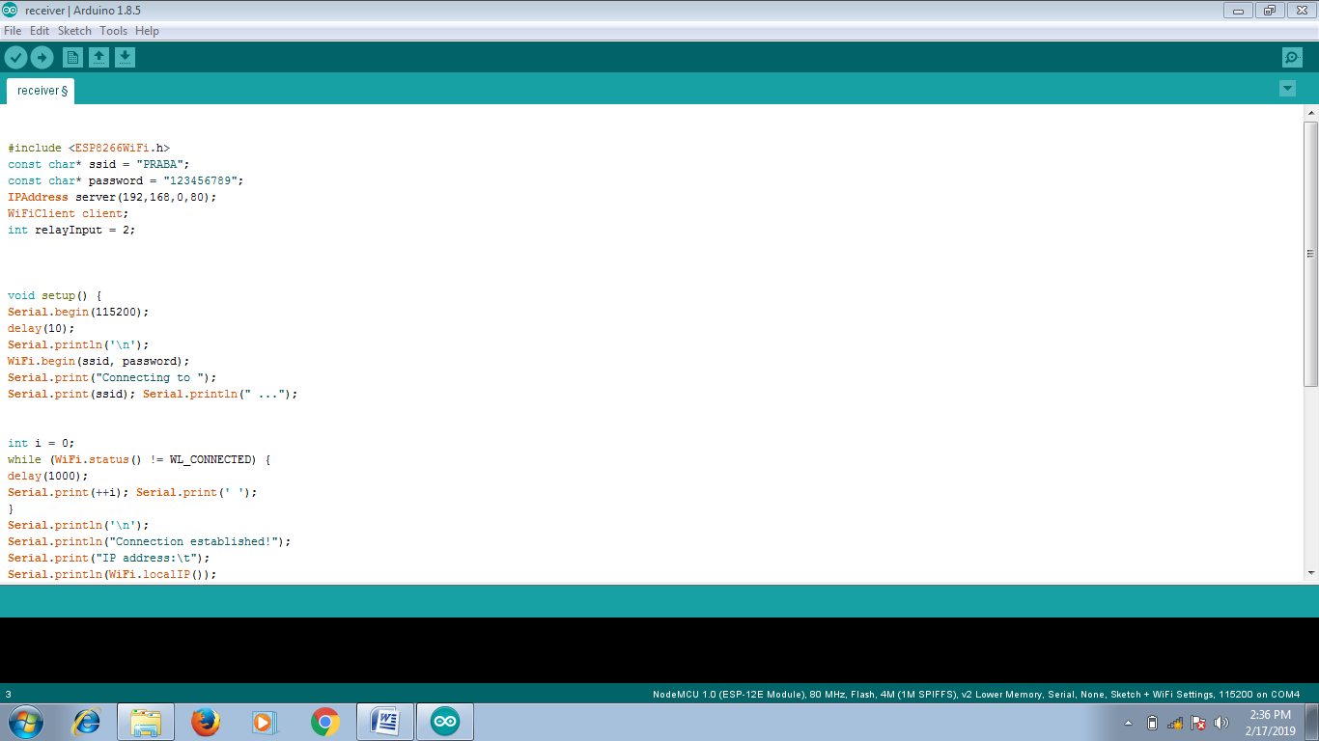

Fig. 3. Basic Program setup between client and server in ardiuno IDE

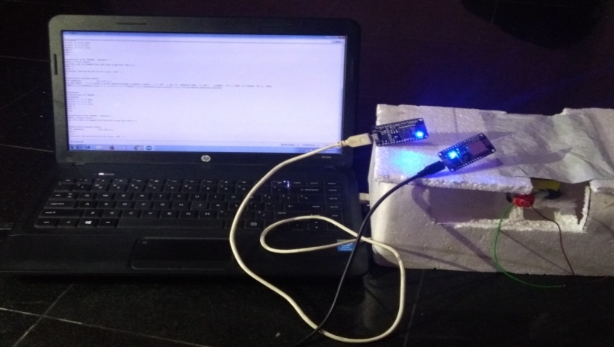 Fig. 4. Paired connection between Server and client

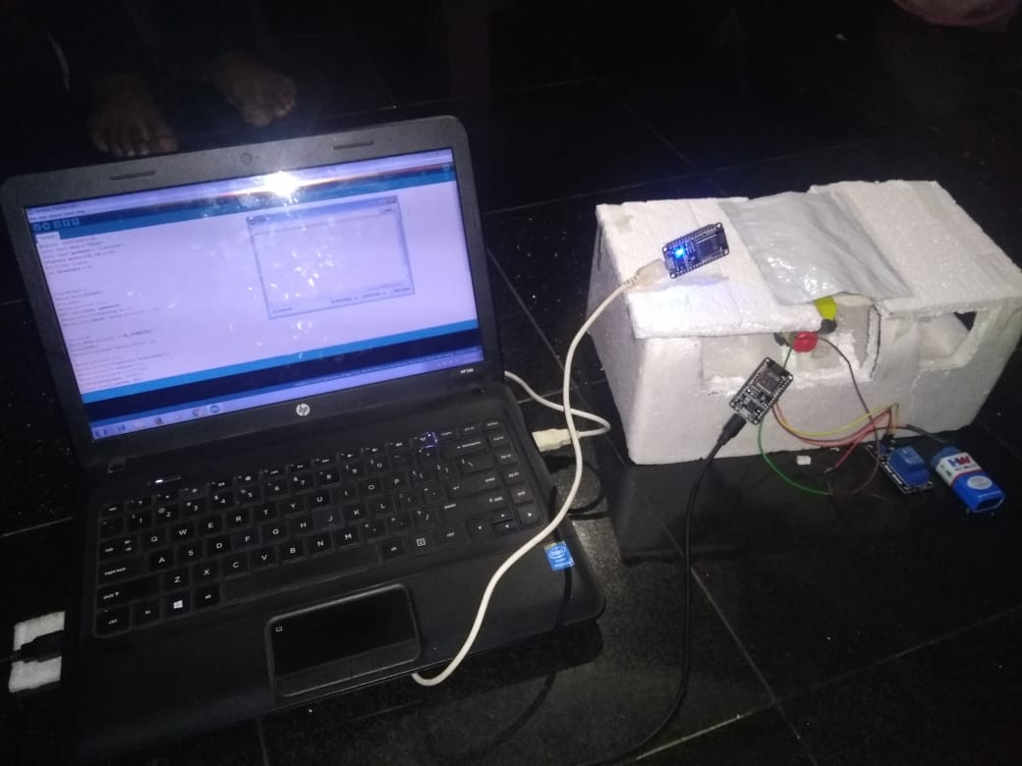 Fig. 5. Woking of Hump while crossing the emergency vehicle (server) in the road

1. **conclusion**

We have implemented automatic hump controller for emergency vehicles by wifi technology without any intervention of human beings.Its cause the emergency vehicles to move same speed while crossing the hump. It is efficient and effective.

**References**

1. “Automatic control signal operated road blocker by using electricity from speed breaker”, Shubham Shinde, Akshay Thombre, Hrishikesh Tupe, Sunil Chavan, Rohan Thombre, Dipak Deshmukh,Vol-3 Issue-3 2017, *IJARIIE-ISSN(O)-2395-4396.*
2. Automatic Pothole and Speed Breaker Detection using Android System*,* Vinay Rishiwal*, Hamshan Khan Department of CSIT, IET, MJP Rohilkhand University, India. Tejas Networks, Bangalore. May 30 - June 3, 2016, Opatija, Croatia
3. "Automatic Detection and Notification of Potholes and Humps on Roads to Aid Drivers," R. Madli, S. Hebbar, P. Pattar and V. Golla, in *IEEE Sensors Journal*, vol. 15, no. 8, pp. 4313-4318, Aug. 2015.
4. “Electricity Generation from Speed Breakers”,Aniket Mishra, Pratik Kale, Atul Kamble, ||Volume|| 2 |||2013|| ISSN (e): 2319 – 1813 ISSN (p): 2319 – 1805.
5. “Growth rate of motor vehicles in india “,R.D. Sharma ,S Jain,K.Singh,Journal of economics and social studies, Vol 1,2011.
6. “Fundamentals of renewable energy systems”, Mukherjee Chakrabarti,2005, New agr internatonal limited publishers, New Delhi.
7. Non-conventional power plants, Public printing service,Sharma.P.C,2003.